## **Scenario 3: Customers Transfer Funds Between Accounts**

### **Objective**

Create a **stored procedure TransferFunds** that:

* Takes **from-account ID**, **to-account ID**, and **amount** as parameters
* Checks if the **source account has sufficient balance**
* If yes, transfers the funds
* If not, raises an appropriate error message
* Commits the transaction and displays a message

## **📖 Approach**

* Use SELECT ... INTO to fetch source account balance
* Use IF to check sufficiency
* If sufficient:
  + Deduct amount from source
  + Add amount to destination
  + Commit
* If insufficient:
  + Raise application error

## **Stored Procedure Code**

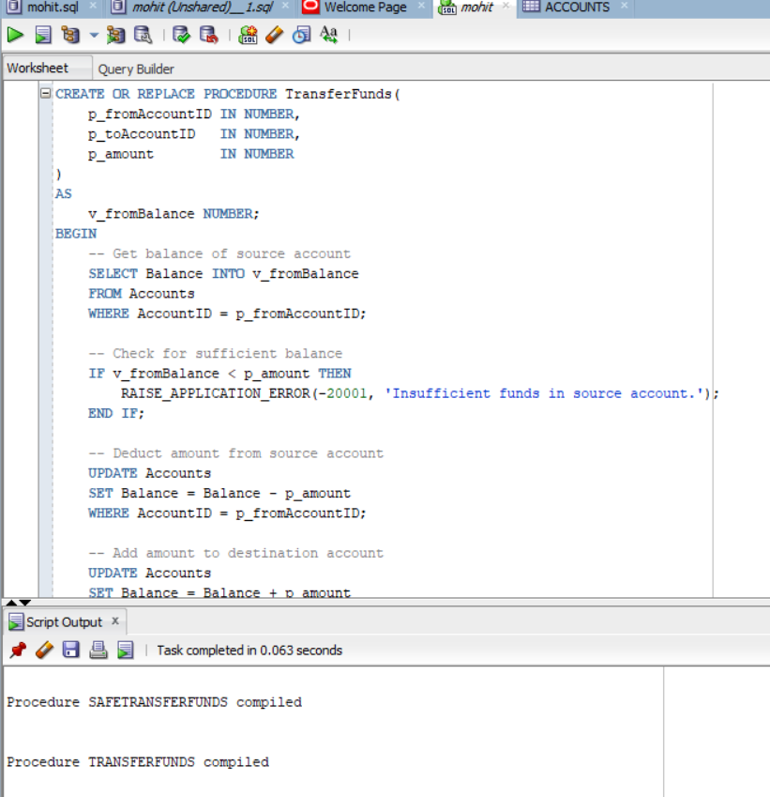

## **How to Call the Procedure**

EXEC TransferFunds(1, 2, 500);

## **Expected Behavior**

|  |  |
| --- | --- |
| **Case** | **Action** |
| Sufficient funds in source | Transfers amount, commits transaction, prints success |
| Insufficient funds | Raises error, rolls back, prints error message |

**DBMS Output (example):**

Funds transferred successfully.

or

Error occurred: ORA-20001: Insufficient funds in source account.